[STEPS OF GENERATION OF CODE USING VISUAL DIAGRAM]

1: FIRST WE MADE CLASS DIAGRAM OF OUR MAIN PROJECT BELOW ARE THE PICS OF CLASS DIAGRAM
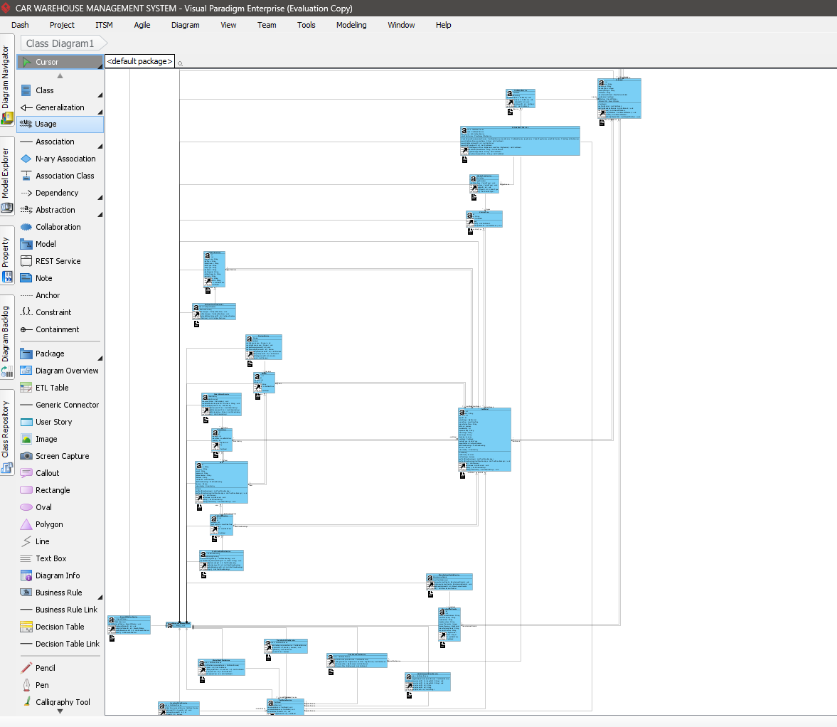
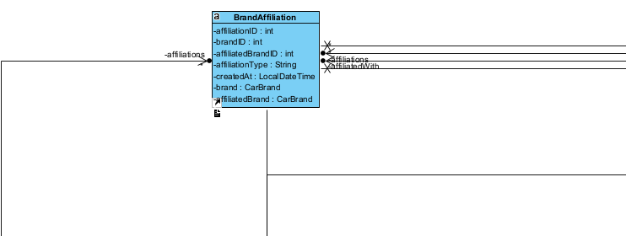
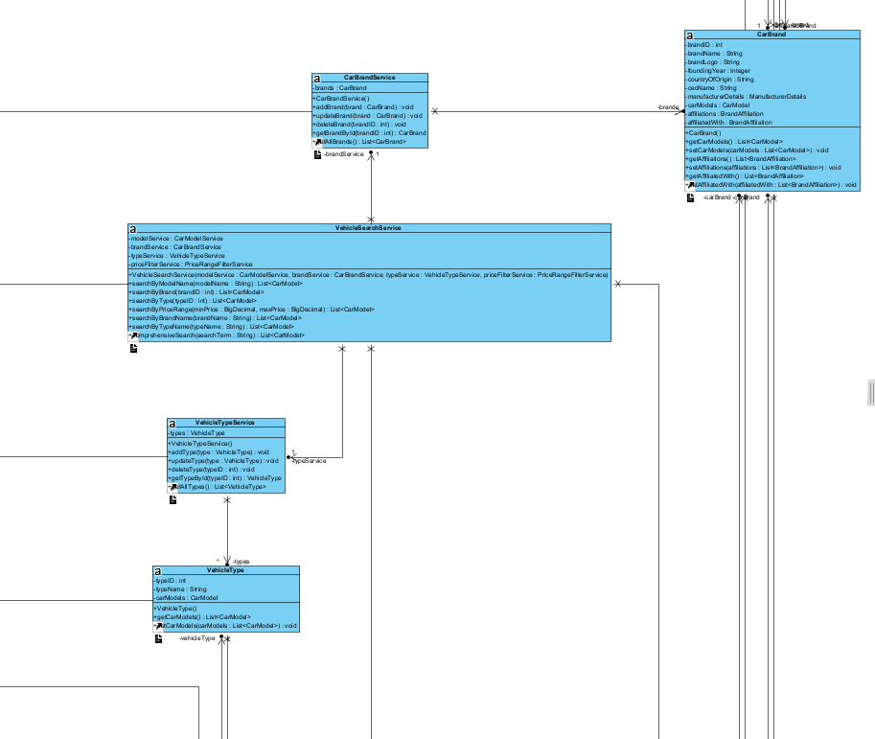
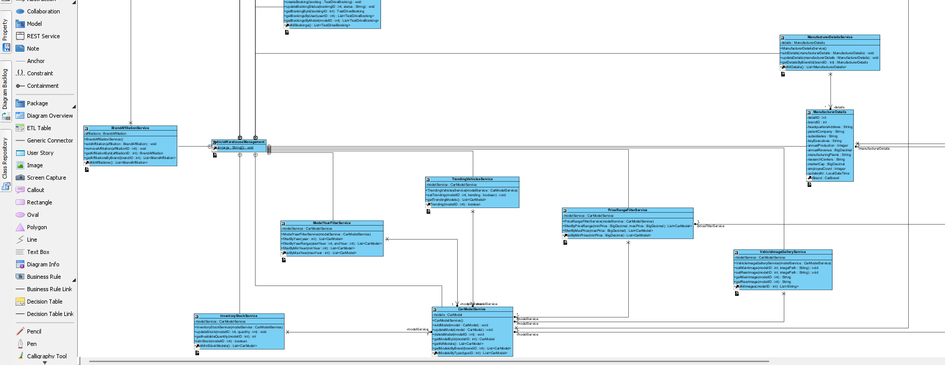

2: CONVERT THE DIAGRAM INTO CODE FOR THIS
GO TO TOOLS -> CODE -> INSTANT GENERATOR
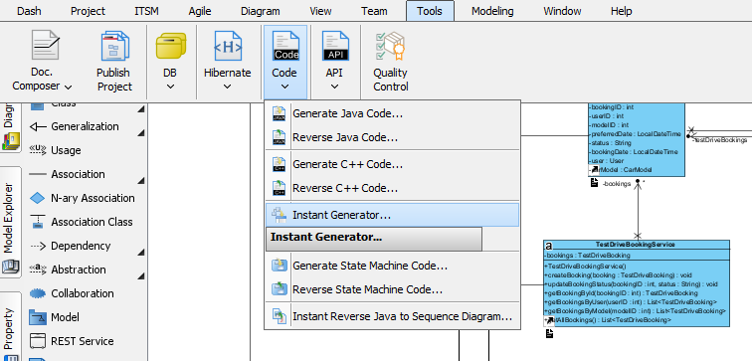

SELECT CLASS DIAGRAM FILES
THEN SELECT OUTPUT PATH
THEN GENERATE
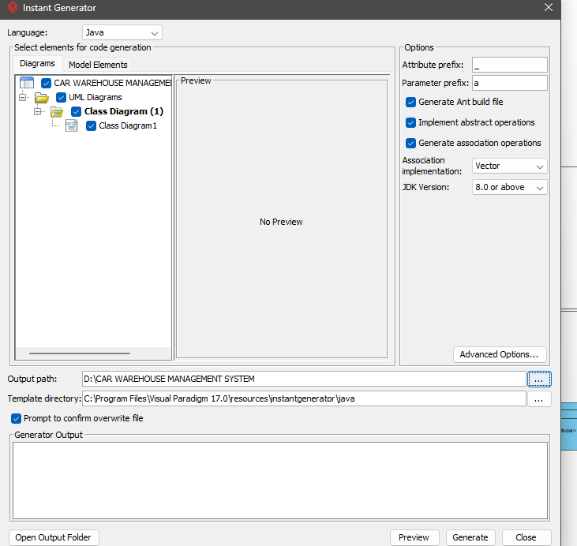

GENERATION COMPLETE
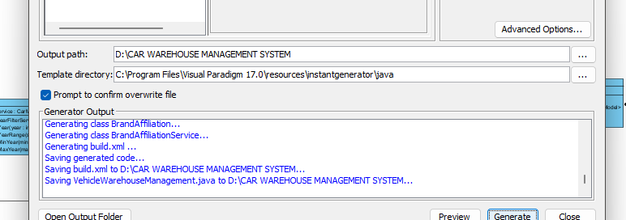

CODE GENERATED AT 21:47
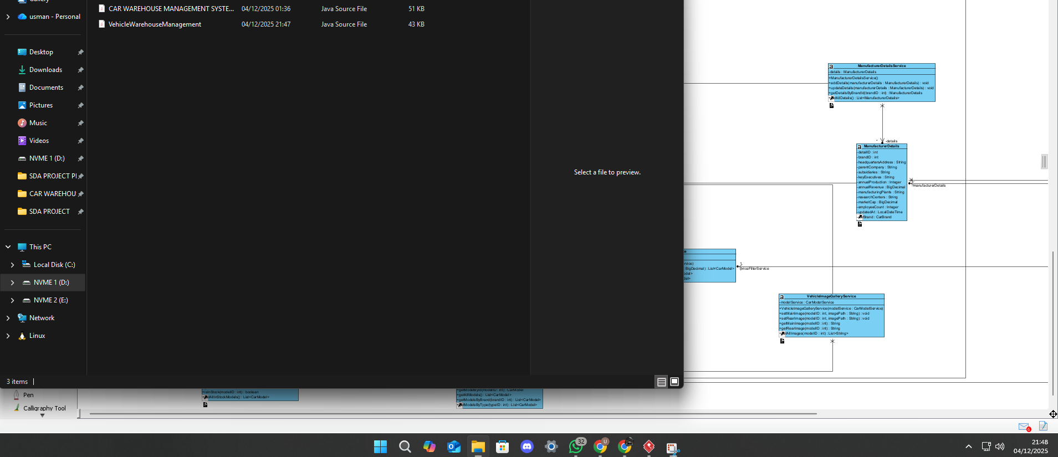

CODE:
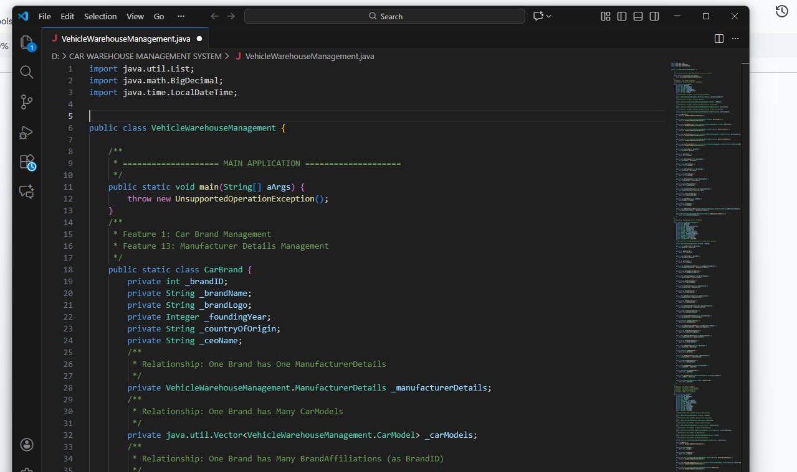

[FILE OF CODE PROVIDED IN THIS FOLDER]

